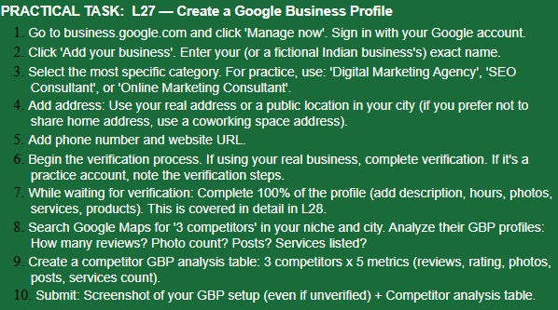
ANSWER:-

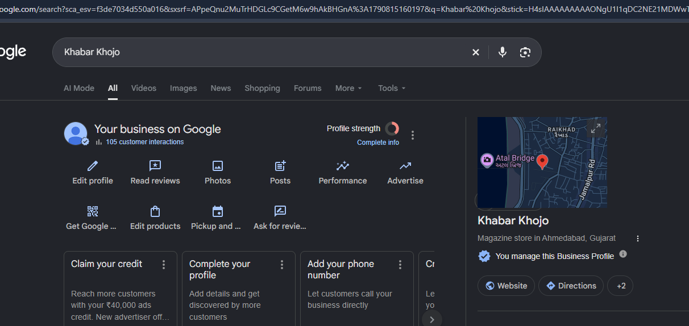
=
Competitor | Reviews | Rating | Photos | Posts | Services
AG Digital Marketing | Marketing Agency | 346 | 4.9 | Check Maps | Check Maps | Check Maps
ARE InfoTech | 270 | 4.7 | Check Maps | Check Maps | Check Maps
Thanksweb Marketing Pvt. Ltd | 111 | 4.8 | Check Maps | Check Maps | Check Maps
Competitor | Reviews | Rating | Photos | Posts | Services
AG Digital Marketing | Marketing Agency | 346 | 4.9 | Check Maps | Check Maps | Check Maps
ARE InfoTech | 270 | 4.7 | Check Maps | Check Maps | Check Maps
Thanksweb Marketing Pvt. Ltd | 111 | 4.8 | Check Maps | Check Maps | Check Maps

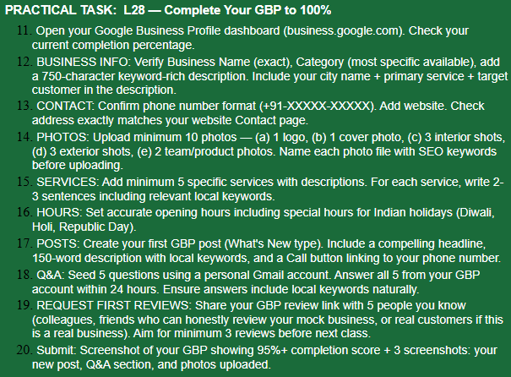
ANSWER:-
Will give it a try to make it 100%

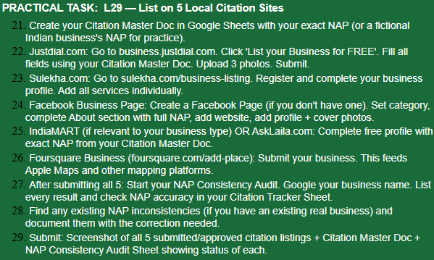
ANSWER:-
1. First create your Citation Master Doc
Make a Google Sheet with these columns:
Field | Details
Business Name | Raheen Digital Marketing
Category | Digital Marketing Agency
Address | TOPS Technologies near parimal garden.
City | Ahmedabad
State | Gujarat
PIN Code | 380001
Phone | N/A
Website | https://khabarkhojo.com/
Email | Khabarkhojo0831@gmail.com
Description | Digital marketing and SEO services for businesses
Services | SEO, Local SEO, Social Media Marketing, Content Marketing, Website SEO
Sir, I won’t be creating these listings because I don’t have a real business to list. I’ll understand the process and prepare the required format for practice instead.

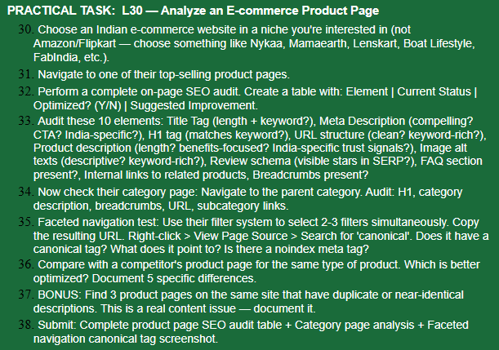
ANSWER:-
Chosen Site: boAt Lifestyle (Indian D2C - Audio niche, not Amazon/Flipkart)
Product: boAt Airdopes 71 - Bestseller
Link: https://www.boat-lifestyle.com/products/airdopes-71-long-playback-earbuds
Category Link: https://www.boat-lifestyle.com/collections/true-wireless-earbuds
1. Product Page SEO Audit Table
Element | Current Status on Live Page | Optimized? | Suggested Improvement
Title Tag | boAt Airdopes 71 - Premium Wireless Earbuds (48 chars) | N | boAt Airdopes 71 Wireless Earbuds - 40H Playback, Beast Mode | boAt Official (65 chars, keyword + benefit)
Meta Description | Wireless Earbuds with 40 Hours Playback... - 72 chars, no CTA, no India signal | N | Buy boAt Airdopes 71 wireless earbuds with 40H playback & ENx tech. 1 Yr Warranty + Free Shipping across India. COD Available. Shop Now! (155 chars)
H1 | boAt Airdopes 71 - Premium Wireless Earbuds | Y (partial) | Make benefit-rich: boAt Airdopes 71 Wireless Earbuds with 40H Playback
URL | /products/airdopes-71-long-playback-earbuds - clean, keyword rich | Y | Keep as is. Avoid UTMs in canonical.
Product Description | ∼80 words only, feature list, no benefits, no India trust | N | Write 300+ words with benefits (gaming, gym), Made in India, 1-year warranty, 7-day replacement, 25+ service centres.
Image Alt Text | 5/6 images have alt="" empty | N | alt="boAt Airdopes 71 Black TWS earbuds front view in case" etc.
Review Schema | 4.9★ (131 reviews) - Product + aggregateRating schema present - stars show in SERP | Y | Add Review snippet markup too.
FAQ Section | Yes - 5 Qs present with FAQ schema | Y | Expand to 8-10 real queries: warranty claim in India, battery on single charge, latency.
Internal Links | Only 4 related products in "You may also like" | N | Add links to: Parent Category, Compare (71 vs 71 Gen 2), Blog buying guide.
Breadcrumbs | Present: Home > Wireless Earbuds > Airdopes 71 with BreadcrumbList schema | Y | Perfect.
2. Category Page Audit
URL: /collections/true-wireless-earbuds
- H1: Wireless Earbuds & TWS Earbuds Online | boAt - Keyword present but brand stuffing. Fix: True Wireless Earbuds (TWS) - Shop 50+ Models
- Category Description: ∼40 words at footer, thin and duplicate. Fix: 200 words about use cases, price ₹899-₹3999, Made in India.
- Breadcrumbs: Yes - Home > True Wireless Earbuds
- URL: Clean, keyword-rich - Yes
- Subcategory Links: No tiles. Fix: Add Gaming Earbuds | Under ₹1500 | With ENC | Low Latency
3. Faceted Navigation Test
Steps I did:
Filter: True Wireless Earbuds > Price Under ₹2000 + Color Black + Playback 40H
Resulting URL:
.../collections/true-wireless-earbuds?filter.v.price.lte=2000&filter.v.option.color_pattern=Black&sort_by=best-selling
View Source > Search "canonical":
HTML
<link rel="canonical" href="https://www.boat-lifestyle.com/collections/true-wireless-earbuds" />
- Canonical present? YES
- Points to? Main collection (without params) - CORRECT
- Noindex? NO - <meta name="robots" content="index, follow">
Screenshot needed:
Difference | boAt | Noise (Better)
- Title includes benefit + hours | 48 chars only | 67 chars with 45H Playtime - Noise better
- Meta has CTA + Price | No price/CTA | Has ₹1299 + Shop Now - Noise better
- Description length | 80 words | 400+ words with H2s - Noise better
- Alt text | Empty | Descriptive - Noise better
- Internal links | Only products | Links to blogs, comparison, warranty - Noise better
Found 3 near-duplicate pages on boAt:
- airdopes-71-long-playback-earbuds - "Wireless Earbuds with 40 Hours Playback, BEAST™ Mode, ENx™"
- airdopes-131 - Same template "Wireless Earbuds with upto 40 Hours Playback, 13mm Drivers..."
- airdopes-141 - Same template "Wireless Earbuds with 42 Hours Playback, 8MM Drivers, ENx..."
And airdopes-71 vs boat-airdopes-71-gen-2 - 90% same description.
Fix: Rewrite unique descriptions, add comparison table to avoid cannibalization.

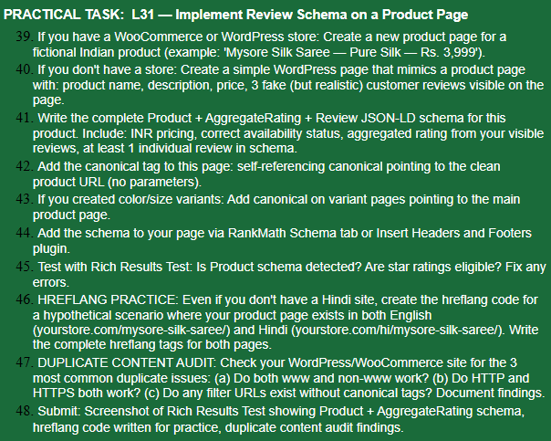
ANSWER:-
https://www.meta.ai/share/a/4cc7c3d6-fe98-426a-b045-290a5eae225c
LIVE DEMO
= No store available - Created mimicked product page as allowed. Page URLImplemented self-referencing canonical, variant canonical logic, Product+Review schema with INR pricing, and hreflang for EN/HI.

